Dress Code for the Black and White Dance 2024
Hosted by BHEA Boy Scout Troop 442
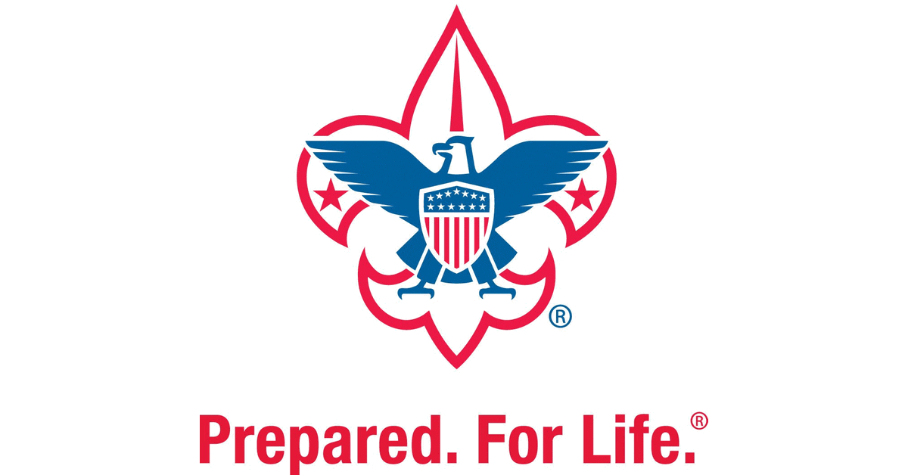

Dress for the Black and White Dance 2024 is semi-formal. Think church clothes. It is not necessary to purchase special formal wear. The theme is, of course, about the colors black and white. We encourage you to wear black, white, or both! Feel free to be creative.
Gentlemen are not required to wear a jacket or tie, but both are welcome.
- Collared shirts and non-blue jeans are preferred.
- Black jeans are fine.
Ladies’ attire, whether pants and blouse, pantsuits, jumpsuits, or dresses should fall within the following guidelines:
- Backless tops, as defined as cut lower than your elbows when your arms are held to your sides, are not permitted. No skin should be showing below this point, including with cut outs or see-through/sheer fabric — like mesh or lace.
- No plunging necklines, cleavage, or midriffs should show. Halter styles are permissible so long as they meet these criteria.
- Strapless tops or dresses may be worn, so long as they meet all other guidelines.
- The shortest point of a skirt or dress, including any slits or overlay of mesh or lace, must be no higher than three inches above the top of the kneecap when standing.

In all cases, male or female, the regular BHEA dress code stands in the event of an omission or misunderstanding. You can find that at our website at https://www.bhea.net/dresscode.

If you have any questions about the 2024 Black and White Dance Dress Code, please email Susan Barlow at membership@bhea.net for clarification.

